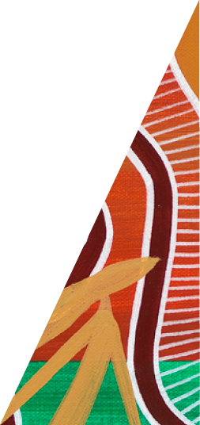Kangaroo Harvesting Program

2023 Annual Report

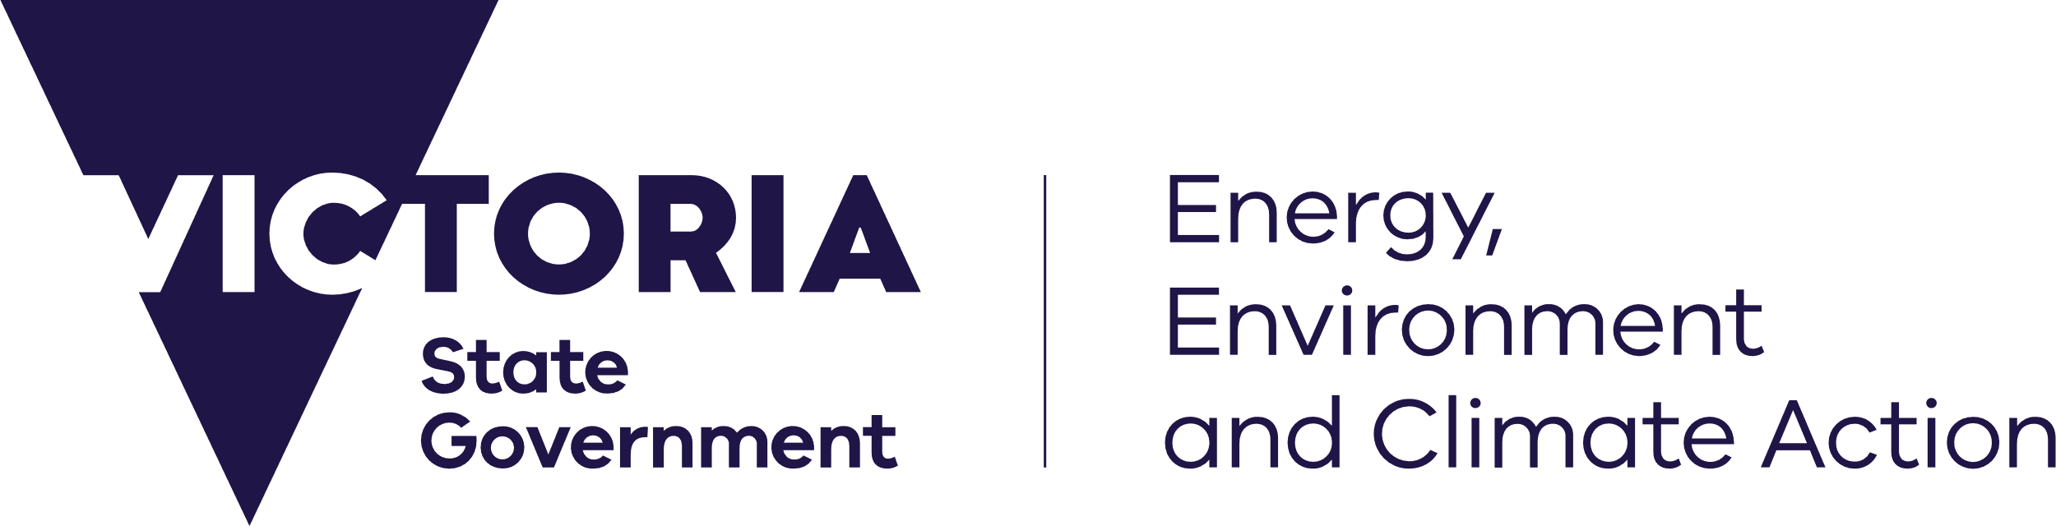



[deeca.vic.gov.au](https://delwpvicgovau-my.sharepoint.com/Users/fionadurante/Downloads/deeca.vic.gov.au)

Acknowledgements

The Department of Energy, Environment and Climate Action would like to acknowledge the Game Management Authority and the Department of Jobs, Skills, Industry and Regions for their contributions to the Kangaroo Harvesting Program and to this report.



We acknowledge and respect Victorian Traditional Owners as the original custodians of Victoria’s land and waters, their unique ability to care for Country and deep spiritual connection to it.

We honour Elders past and present whose knowledge and wisdom   
has ensured the continuation of culture and traditional practices.

DEECA is committed to genuinely partnering with Victorian Traditional Owners and Victoria’s Aboriginal community to progress their aspirations.

© The State of Victoria Department of Energy, Environment and Climate Action January 2024.

Creative Commons

This work is licensed under a Creative Commons Attribution 4.0 International licence, visit the [Creative Commons website](http://creativecommons.org/licenses/by/4.0/) (<http://creativecommons.org/licenses/by/4.0/>).

You are free to re-use the work under that licence, on the condition that you credit the State of Victoria as author. The licence does not apply to any images, photographs, or branding, including the Victorian Coat of Arms, and the Victorian Government and Department logos.

ISSN 2653-8288 – **Online** (**pdf/word**)

Disclaimer

This publication may be of assistance to you, but the State of Victoria and its employees do not guarantee that the publication is without flaw of any kind or is wholly appropriate for your particular purposes and therefore disclaims all liability for any error, loss or other consequence which may arise from you relying on any information in this publication.

Accessibility

To receive this document in an alternative format, phone the Customer Service Centre on 136 186, email [customer.service@delwp.vic.gov.au](mailto:customer.service@delwp.vic.gov.au), or contact National Relay Service on 133 677. Available at [DEECA website](http://www.deeca.vic.gov.au/) (www.deeca.vic.gov.au).

Contents

Introduction 2

2023 Quota 2

Summary of Kangaroo take in Victorian Harvest Zones in 2023 3

KHP data 3

Summary 3

Eastern and Western grey kangaroos 3

Sex ratio of harvested kangaroos 3

Dependent Young 4

ATCW data 5

Summary 5

ATCWs outside of Harvest Zones 5

Total take (ATCW and KHP combined) of kangaroos in Victorian Harvest Zones in 2023 6

Summary 6

Mallee Harvest Zone 6

Compliance and authorisations 7

Harvester authorisation and compliance figures 7

Summary 7

General program updates in 2023 8

Quota management 8

2023 8

2024 8

KHMP 8

Review of the KHMP 2021-2023 8

Public Consultation 8

KHMP 2024-2028 and International Trade 8

Victorian kangaroo abundance survey 9

Research 9

Appendix A: KHP Harvest Zones 2023 10

References 11

# Introduction

The 2023 Kangaroo Harvesting Program (KHP) Annual Report (the Report) has been developed in line with the requirements of the Kangaroo Harvest Management Plan (KHMP) 2021-2023. It captures relevant information on the implementation of the KHP from 1 January 2023 until 31 December 2023.

The Report also includes information on Authority to Control Wildlife (ATCW) figures for grey kangaroos as these figures are considered in determining the annual quota for the KHP. Only Eastern Grey kangaroos (EGK) and Western Grey kangaroos (WGK) can be harvested through the KHP, and as outlined in the KHMP 2021-2023, the quota does not differentiate between species.

The ATCW system allows for the control of wildlife where it is causing damage to property, posing a risk to human health and safety, or impacting other environmental values.

The KHP operates within 7 Victorian Harvest Zones. A map of these Harvest Zones and corresponding local government areas is provided in **Appendix A**.

More information about the KHP, KHMP and ATCWs can be found here:

* [**Kangaroo Harvesting Program (wildlife.vic.gov.au)**](https://www.wildlife.vic.gov.au/our-wildlife/kangaroo-harvesting-program)
* [**Wildlife management and control authorisations | vic.gov.au (www.vic.gov.au)**](https://www.vic.gov.au/wildlife-management-and-control-authorisations)

## 2023 Quota

The 2023 kangaroo harvest quotas were set based on recommendations provided by the Arthur Rylah Institute for Environmental Research (ARI) in the report *Kangaroo harvest quotas for Victoria 2023*(Ramsey, 2022).

ARI uses a spatial harvest model to make recommendations on kangaroo harvest quotas. The model considers the most recent kangaroo population survey results, environmental variables like rainfall, and kangaroo control numbers (through the KHP and ATCW system) to predict changes in kangaroo populations for the years where no survey is undertaken. The model recommends that no more than 10 per cent of the grey kangaroo population can be taken each year. This includes take through both the KHP and under the ATCW system.

The 2023 quota was based on population estimates from an aerial survey in 2022.

Table 1: Kangaroo quotas for Victoria (1 January 2023 – 31 December 2023).

|  |  |  |  |
| --- | --- | --- | --- |
| Harvest Zone | Population* | KHP quota available | Recommended total take (ATCW and KHP) |
| Central | 820,550 | 65,100 | 82,050 |
| Gippsland | 176,550 | 13,600 | 17,650 |
| Lower Wimmera | 556,050 | 41,100 | 55,600 |
| Mallee | 55,900 | 1,550 | 5,600 |
| North East | 355,950 | 11,050 | 35,600 |
| Otway | 189,200 | 15,500 | 18,900 |
| Upper Wimmera | 209,650 | 18,850 | 20,950 |
| **Statewide total** | **2,363,850** | **166,750** | **236,350** |

*\* from modelled estimate provided in Kangaroo harvest quotas for Victoria in 2023 (Ramsey and Scroggie, 2022).*

# Summary of Kangaroo take in Victorian Harvest Zones in 2023

## KHP data

### Summary

Overall, just over 72,000 kangaroos – or three per cent of the statewide estimated population within Harvest Zones – were harvested through the KHP. **Table 2** outlines 2023 KHP statistics for each Harvest Zone.

Approximately 4,000 more kangaroos were harvested in 2023 (72,232) compared to 2022 (68,346). There was 40 per cent more quota available to harvesters in 2023 (166,750) than in 2022 (118,980). The use of quota varied greatly between Harvest Zones.

In 2023, 43 per cent of the available KHP quota was used by harvesters, this is less than the 57 per cent that was used in 2022.

Table 2: Kangaroo Harvesting Program statistics (1 January 2023 – 31 December 2023).

|  |  |  |  |  |
| --- | --- | --- | --- | --- |
| Harvest Zone | KHP quota available | KHP quota harvested | % Available quota harvested | % Harvest Zone population harvested |
| Central | 65,100 | 24,689 | 38% | 3% |
| Gippsland | 13,600 | 8,039 | 59% | 5% |
| Lower Wimmera | 41,100 | 19,463 | 47% | 4% |
| Mallee | 1,550 | 1,400 | 93% | 3% |
| North East | 11,050 | 6,588 | 60% | 2% |
| Otway | 15,500 | 7,919 | 51% | 4% |
| Upper Wimmera | 18,850 | 4,134 | 22% | 2% |
| **Statewide total** | **166,750** | **72,232** | **43%** | **3%** |

Harvesters are required to report on the number of each species, sex harvested and any dependant young euthanised due to harvesting activities upon completion of each harvest job.

### Eastern and Western grey kangaroos

Harvesters reported 1,897 Western Grey Kangaroos, and 71,726 Eastern Grey Kangaroos were harvested. The variance in the combined total of EGK and WGK reported by harvesters and the total KHP quota harvested (**Table 2**) is due to harvester recall-bias. This has no impact on population modelling as the number of quota harvested is closely monitored through the tag system and these numbers are what contribute to population estimates.

To ensure robust data and reduce discrepancies for 2023, reports of harvested WGKs have only been applied in Harvest Zones (Mallee, Upper Wimmera, and Lower Wimmera) where the species is known to have existing populations.

GMA will provide further support for harvesters to correctly identify species when using the reporting app.

### Sex ratio of harvested kangaroos

There is a known bias towards harvesting male kangaroos in commercial harvest programs. In 2023 harvesters reported 23,321 female kangaroos were harvested under the KHP.

The risk of male bias was considered by ARI in the report *A spatial harvest model for kangaroo populations in Victoria* (Scroggie and Ramsey, 2020), which indicates that there is minimal ecological risk to kangaroo populations when harvesting programs target males in preference to females given the regular monitoring that occurs to ensure kangaroo harvesting is sustainable.

### Dependant Young

A total of 2,513 dependant young were reported euthanised by harvesters in 2023. Dependant young of harvested female kangaroos must be euthanised humanely in line with requirements under the *National Code of Practice for the Humane Shooting of Kangaroos and Wallabies for Commercial Purposes* (AgriFutures, 2020)*.*

The number of dependant young euthanised does not contribute to the data used to determine the KHP quota. The quota is determined using modelling and population estimates from aerial and ground surveys and these surveys do not count dependant young.

## ATCW data

### Summary

Wildlife can sometimes cause damage to property or farmland, or can adversely impact the environment. Wildlife can also pose a threat to human safety, or where the species is over-abundant, lead to animal welfare issues. Wildlife management may be needed to manage these issues. In these cases, land managers may apply for an ATCW to allow them to manage impacts.

The Conservation Regulator undertakes rigorous assessments of all ATCW applications to ensure that claims of damage are substantiated, and all practical non-lethal measures have been exhausted prior to any lethal control being approved. This includes ensuring consideration of exclusion measures such as fencing or netting where they can be practically applied. ATCWs for kangaroos operate alongside the KHP and can be issued to private landholders and public land managers.

The *Wildlife Act 1975* (Wildlife Act) requires that wildlife control be undertaken with consideration of animal welfare and environmental values. All ATCWs include strict conditions to ensure that animals are controlled humanely.

A summary of grey kangaroos approved for control under an ATCW in each KHP zone from January-December 2023 is shown in **Table 4**. As noted above, these figures are included in this report to enable an assessment of total kangaroo control across the KHP and the ATCW system.

It is important to note that the ATCW figures reported in **Table 4** are the maximum numbers of kangaroos approved for control during this period. The actual number controlled by a landholder may be lower than the maximum authorised. This may occur if, for example, kangaroos disperse because of shooting activities.

There was a 28 per cent increase in number of grey kangaroos approved for control under ATCWs within Harvest Zones in 2023 (75,375) from 2022 (58,771).

Table 4: Number of kangaroos (EGK and WGK combined) approved for control under an ATCW (1 January – 31 December 2023).

|  |  |  |  |
| --- | --- | --- | --- |
| Harvest Zone | Predicted ATCW | Kangaroos approved for control | % of est. population approved for control |
| Central | 16,950 | 21,538 | 3% |
| Gippsland | 4,050 | 4,161 | 2% |
| Lower Wimmera | 14,500 | 13,341 | 2% |
| Mallee | 4,050 | 5,963 | 11% |
| North East | 24,550 | 23,813 | 7% |
| Otway | 3,400 | 3,916 | 2% |
| Upper Wimmera | 2,100 | 2,643 | 1% |
| **Statewide total** | **69,600** | **75,375** | **3%** |

### ATCWs outside of Harvest Zones

The data on ATCWs issued for EGK or WGK outside of KHP Harvest Zones in 2023 is not included in this report. The Conservation Regulator publishes annual ATCW data for all species across Victoria on its website: [**vic.gov.au/operational-licences-permits-issued-conservation-regulator**](http://www.vic.gov.au/operational-licences-permits-issued-conservation-regulator)

## Total take (ATCW and KHP combined) of kangaroos

### Summary

In 2023 less than 7 per cent (147,607) of Victoria’s grey kangaroo population was controlled through the KHP and approved for control under the ATCW system within the seven Harvest Zones, (**Table 5**). This is within the 10 per cent maximum (236,350) recommended by ARI. The total take in 2022 was 127,117.

Table 5: Kangaroo Harvesting Program statistics (1 January 2023 – 31 December 2023).

|  |  |  |  |  |  |
| --- | --- | --- | --- | --- | --- |
| Harvest Zone | Recommended total take (Predicted ATCW and KHP quota available) | KHP  (Quota harvested) | ATCW  (Kangaroos approved for control) | Total take  (ATCW and KHP) | Total take  (% of population) |
| Central | 82,050 | 24,689 | 21,538 | 46,227 | 6% |
| Gippsland | 17,650 | 8,039 | 4,161 | 12,200 | 7% |
| Lower Wimmera | 55,600 | 19,463 | 13,341 | 32,804 | 6% |
| Mallee | 5,600 | 1,400 | 5,963 | 7,363 | 13% |
| North East | 35,600 | 6,588 | 23,813 | 30,401 | 9% |
| Otway | 18,900 | 7,919 | 3,916 | 11,835 | 6% |
| Upper Wimmera | 20,950 | 4,134 | 2,643 | 6,777 | 3% |
| **Statewide total** | **236,350** | **72,232** | **75,375** | **147,607** | **6%** |

### Mallee Harvest Zone

The Department of Energy, Environment and Climate Action (DEECA) reviews the KHP quota quarterly and can make adjustments to the quota to ensure take is sustainable. As part of this, considerations are given to approvals under the ATCW system, remaining quota and kangaroo populations at zone and statewide levels.

The total take in the Mallee Zone exceeded the recommended maximum. This is due to higher than predicted ATCW permits for control of kangaroos on public land as part of kangaroo management plans.

DEECA identified potential for higher than predicted levels of take in late June, close to the release of the final allocation of quota in the Mallee zone. After thorough assessment, DEECA concluded that releasing the final quota would not have any material impact on the broader statewide kangaroo population or the kangaroo population in the Mallee Harvest Zone.

No adjustments were made due to the overall low quota available for that zone (1,500 for 2023) and there being only 500 quota remaining to be released at the time. A reduction or suspension of the remaining quota would not have made any significant impact on the total take given it represents less than 1% of the estimated population in the Mallee.

In response to the higher than predicted levels of control in the Mallee Harvest Zone in 2023, and the predicted levels of take for 2024 through the ATCW system, no KHP quota has been assigned to this zone for 2024.

A harvest quota of 10 to 20 per cent of kangaroo populations is considered sustainable. Victoria takes a conservative approach (10 per cent total control) when setting the kangaroo harvest quotas to ensure overharvesting is prevented. The Department considered this in its assessment of releasing the final quota.

# Compliance and authorisations

## Harvester authorisation and compliance figures

### Summary

The Game Management Authority (as an agent of the Department of Jobs, Skills, Industry and Regions (DJSIR)), delivers compliance activities and issue KHP harvester authorisations. Compliance activities summarised in this report do not cover the ATCW system - this is overseen by the Conservation Regulator.

In 2023, compliance activities were undertaken in accordance with the 5 compliance priorities (Harvester Competency, Animal Welfare, Sustainability, Authorisations, and Public Safety) of the 2023 KHP Compliance Plan.

There were 17 active harvesters in 2023. An active harvester under the 2023 KHP Compliance Plan, is a harvester who was active throughout the previous four quarters.

All substantiated offences were minor in nature, relating to reporting requirements and application of correct tags (**Table 8)**.

Table 6: Harvester authorisations.

|  |  |
| --- | --- |
| Activity | Total |
| Number of applications for authorisations received | 26 |
| Number of applications authorised after meeting requirements | 22 |
| Number of authorisations suspended or cancelled | 0 |

Table 7: Harvesters who received KHP quota for each Harvest Zone*

|  |  |
| --- | --- |
| Harvest Zone | Total |
| Central | 75 |
| Gippsland | 35 |
| Lower Wimmera | 51 |
| Mallee | 1 |
| North East | 44 |
| Otway | 34 |
| Upper Wimmera | 27 |

*\*Harvesters may operate across more than one Harvest Zone*

Table 8: Compliance statistics summary 2023.

|  |  |
| --- | --- |
| Activity | Total |
| Number of audits conducted on harvester return data | 2,749 |
| Percentage of active harvesters subject to programmed in-field audits | 158% |
| Number of investigations | 4 |
| Number of offences substantiated | 4 |

# General program updates in 2023

## Quota management

### 2023

In 2023, quotas were released quarterly with generally one quarter of the quota being made available to harvesters for each Harvest Zone in January, April, July, and October.

When applying for quotas, harvesters must specify the Harvest Zone in which they are applying for a quota. Tags (colour coded and numbered) are then posted to harvesters for attachment to kangaroos at the time of harvesting. Harvesters must only harvest the number of kangaroos they have been allocated tags for, and only in the zone the tag specifies.

DEECA monitors quota consumption for the KHP alongside permitted control through the ATCW system to ensure the level of take across the two systems is within sustainable limits. As recommended by ARI, if the number of kangaroos taken across both the KHP and ATCW system approaches 10 per cent of the estimated populations, action may be taken to limit overall take to ensure kangaroo populations remain sustainable.

No quota adjustments were made in 2023.

### 2024

Harvest quotas will continue to be released quarterly in 2024 – scheduled for January, April, July, and October. This enables DEECA to adjust the quota throughout the year in response to any events (for example flooding) that may threaten the sustainability of kangaroo populations.

The 2024 quota is based on the ARI’s recommendation in the report *Kangaroo harvest quotas for Victoria, 2024 (*Ramsey, 2023*)*.

## Kangaroo Harvest Management Plan

In Victoria, the Kangaroo Harvest Management Plan (KHMP), sets the requirements for the KHP and commercial kangaroo harvesting has been allowed since 1 October 2019.

### Review of the KHMP 2021-2023

The KHMP 2021-2023 expired on 31 December 2023. A review of the KHMP, including public consultation, was undertaken as part of the development of the KHMP 2024-2028.

The review of the KHMP 2021-2023 only related to the objectives and requirements within the KHMP, and not legislative influences surrounding it. The Wildlife (Interim) Regulations 2023, the Wildlife Act, KHP and ATCWs were not in the scope of the review.

### Public Consultation

In June 2023, DEECA delivered a public consultation process on the KHMP 2021-2023 via the Engage Victoria platform. The consultation period ran from 16 June to 11 July, with 716 submissions received.

The public consultation summary report can be found here:

* [**https://engage.vic.gov.au/download/document/33705**](https://engage.vic.gov.au/download/document/33705)

### KHMP 2024-2028 and International Trade

The KHMP 2024-2028 has been approved by the Secretary of DEECA and came into effect on 1 January 2024.

The Plan has been submitted to the Department of Climate Change, Energy, the Environment and Water (DCCEEW) seeking approval for it to be declared an approved Wildlife Trade Management Plan (WTMP). This will provide for Victorian harvested kangaroo products obtained through the KHP to be exported internationally.

As part of this process, DCCEEW conducted a public consultation in 2023 and will assess the KHMP 2024-2028 against the *Environment Protection and Biodiversity Conservation Act 1999* (EPBC Act).

The previous KHMP 2021-2023 was recognised under the EPBC Act as a Developmental Wildlife Trade Operation (DWTO) which allowed for Victorian harvested kangaroo products to be exported internationally. The DWTO expired on 10 December 2023.

Until the Commonwealth Minister for the Environment and Water declares the KHMP 2024-2028 an approved WTMP, Victorian harvested kangaroo products cannot be exported internationally unless evidence is produced that the kangaroos were harvested before 10 December 2023 under the pre-existing DWTO.

## Victorian kangaroo abundance survey

A statewide aerial survey was conducted in September and October 2022. The survey results were used to estimate kangaroo abundance within the 7 Victorian Harvest Zones. The survey builds on data gathered from previous surveys in 2017, 2018 and 2020. The results of the survey are provided in the ARI report *Statewide abundance of kangaroos in Victoria 2022 (*Moloney et al., 2023*)* and were used to set the harvest quota for 2023 and 2024.

The results found that there were more than 2.3 million grey kangaroos in Victoria, an increase of 24 per cent from the previous survey in 2020. The next survey will be undertaken in 2024 and will include both aerial and ground surveys.

## Research

Under the KHMP 2021-2023, the assessment of kangaroo populations for management purposes was undertaken using a design-based approach. A new model-based approach has been developed and will be used for grey kangaroo population estimates under the KHMP 2024-2028.

The new model-based approach examines relationships between kangaroo densities along survey transects and the associated habitat or climate variables of those areas. These relationships are then used to predict kangaroo abundance across a Harvest Zone which can provide insight into the habitat preferences of grey kangaroos, as well as the ability to make predictions of kangaroo abundance for smaller areas than is possible with the previous design-based approach.

Initial investigations of the model-based approach indicate it can improve precision of population estimates (Scroggie et al., submitted).

Adoption of the new model-based approach will allow better flexibility for the setting of sustainable harvest quotas by allowing them to be set for any arbitrary area. For example, quota could be set for a modified Harvest Zone that excluded areas affected by emergencies such as bushfires or floods.

# Appendix A: KHP Harvest Zones 2023

**Figure 1. Map of Victorian kangaroo harvest zones**

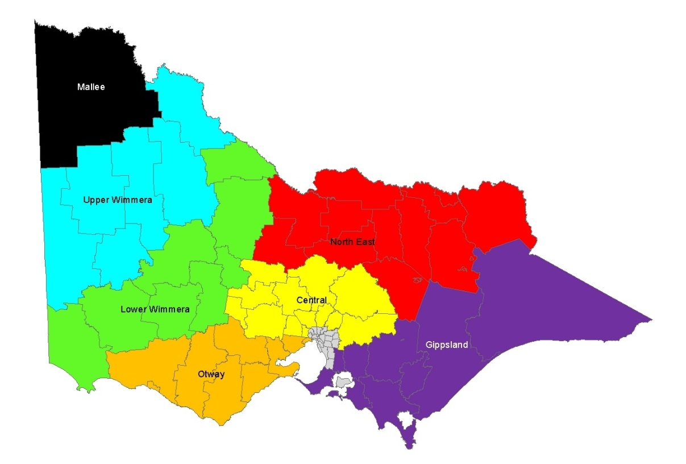

Table 1. Local Government Areas contained in each kangaroo Harvest Zone in Victoria.

|  |  |  |  |  |  |  |  |
| --- | --- | --- | --- | --- | --- | --- | --- |
| **Central** | **Gippsland** | **Lower Wimmera** | **Mallee** | **North East** | **Otway** | **Upper Wimmera** | |
| Ballarat  Brimbank  Hepburn  Hume  Macedon Ranges  Melton  Mitchell  Moorabool  Mt Alexander  Murrindindi  Nillumbik  Whittlesea  Yarra Ranges | Bass Coast  Baw Baw  Cardinia  Casey  East Gippsland  Latrobe  Mornington Peninsula  South Gippsland  Wellington | Ararat  Central Goldfields  Gannawarra  Glenelg  Loddon  Northern Grampians  Pyrenees  Southern Grampians | Mildura | Alpine  Benalla  Campaspe  Greater Bendigo  Greater Shepparton  Indigo  Mansfield  Moira  Strathbogie  Towong  Wangaratta  Wodonga | Colac Otway  Corangamite  Golden Plains  Greater Geelong  Hobsons Bay  Moyne  Surf Coast  Warrnambool  Wyndham | Buloke  Hindmarsh  Horsham  Swan Hill  West Wimmera  Yarriambiack | |
| **Exclusion Zone (No harvesting, ATCWs only)** | | | | | | |
| Banyule  Bayside  Boroondara | Greater Dandenong  Darebin  Frankston | French Island  Glen Eira  Kingston | Knox  Manningham  Maribyrnong | Maroondah  Melbourne  Moonee Valley | Merri-bek  Port Phillip  Queenscliff | Stonnington  Whitehorse  Yarra City | |

# References

AgriFutures 2020*. National Code of Practice for the Humane Shooting of Kangaroos and Wallabies for Commercial Purposes.* AgriFutures Australia Publication No. 20-126.

Department of Energy, Environment and Climate Action (DEECA) 2021. *Victorian Kangaroo Harvest Management Plan 2021- 2023*. Department of Energy, Environment, and Climate Action, Victoria.

Moloney, P.D., Ramsey, D.S.L., and Scroggie, M.P. (2023). *State-wide abundance of kangaroos in Victoria: Results from the 2022 aerial survey*. Arthur Rylah Institute for Environmental Research Technical Report Series No. 356. Department of Energy, Environment and Climate Action, Heidelberg, Victoria.

Ramsey, D.S.L. (2022). *Kangaroo harvest quotas for Victoria, 2023*. *Arthur Rylah Institute for Environmental Research Technical Report Series No. 349*. Department of Energy, Environment, and Climate Action, Heidelberg, Victoria.

Ramsey, D.S.L. (2023). *Kangaroo harvest quotas for Victoria, 2024*. *Arthur Rylah Institute for Environmental Research Technical Report Series No. 371*. Department of Energy, Environment, and Climate Action, Heidelberg, Victoria

Scroggie, M.P., Moloney, P. and Ramsey, D.S.L. (2023). *Spatio-temporal trends in the abundance of grey kangaroos in Victoria, Australia*. Wildlife Research (submitted).

Scroggie, M.P. and Ramsey, D.S.L. (2020). *A spatial harvest model for kangaroo populations in Victoria*. *Arthur Rylah Institute for Environmental Research Technical Report Series No. 315*. Department of Energy, Environment and Climate Action, Heidelberg, Victoria.