# Kangaroo Harvesting Program

# 2025 quota determination

Commercial quota for 1 January to 31 December 2025

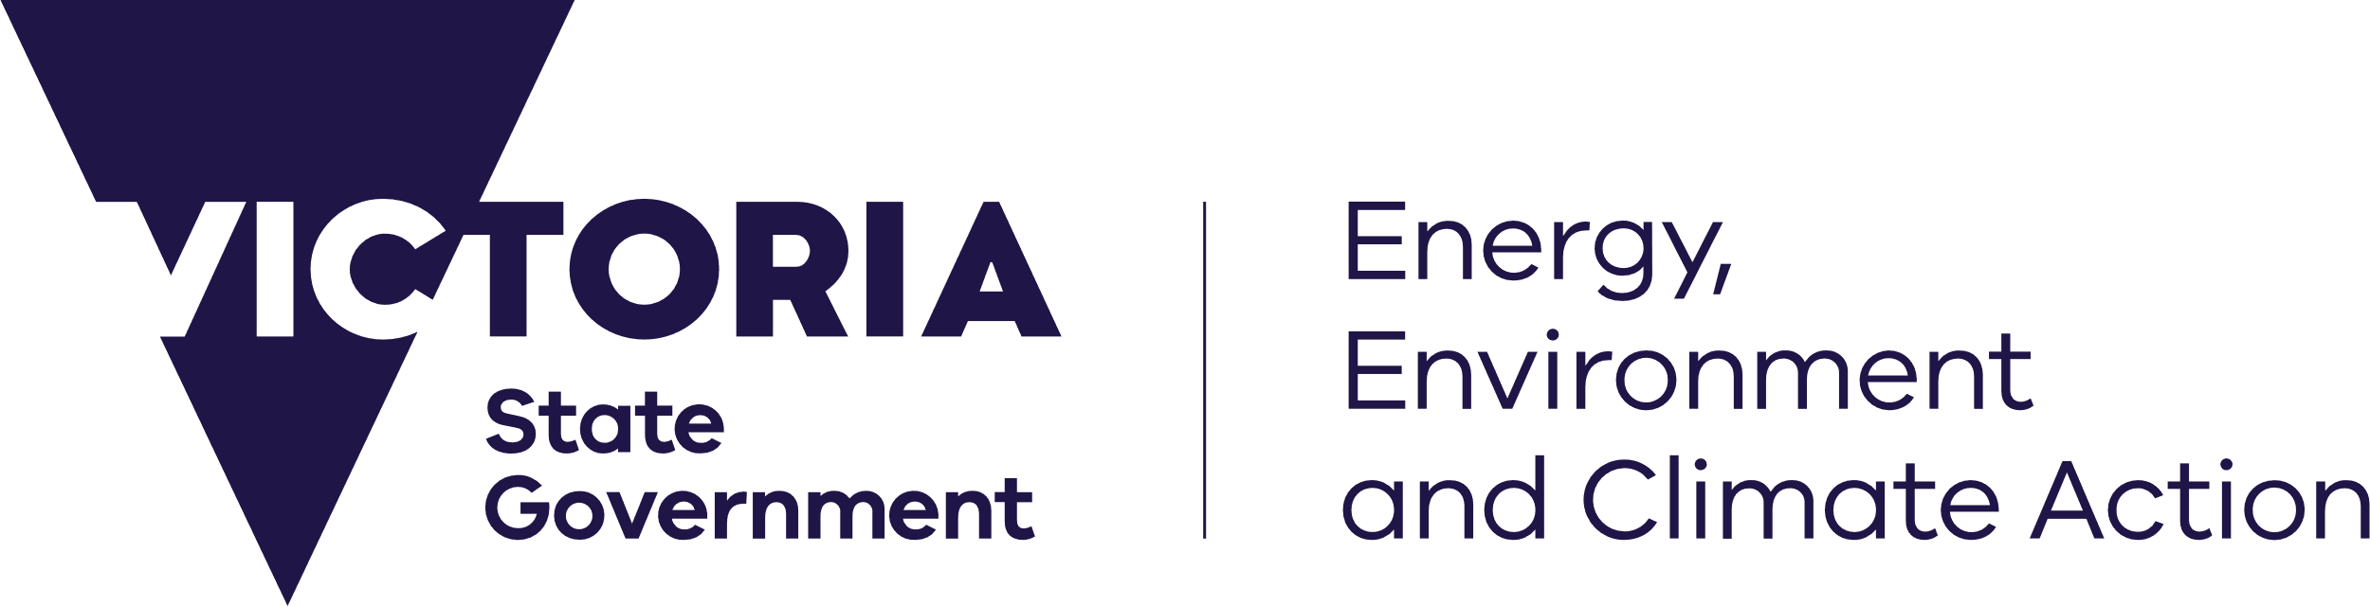

#### Kangaroo Harvesting Program

The Kangaroo Harvesting Program (KHP) allows for commercial harvesting of grey kangaroos in Victoria. Commercial harvesting is authorised by the *Kangaroo Harvest Management Plan 2024-2028* (KHMP) under the *Wildlife Act 1975*. The KHMP requires the Secretary of the Department of Energy, Environment and Climate Action (DEECA) to set an annual commercial quota, which is the maximum number of eastern and western grey kangaroos that can be harvested while maintaining sustainable kangaroo populations.

Determination of the commercial quota must account for the predicted number of Authority to Control Wildlife (ATCW) permits likely to be issued for lethal control of kangaroos over the calendar year. Landholders can apply to the Conservation Regulator for an ACTW at any time.

The take of kangaroos through both commercial harvesting and the ACTW system is monitored throughout the year, and the commercial quota can be reduced or suspended as needed to ensure kangaroo populations are sustainable.

#### 2025 commercial quota

Since commercial kangaroo harvesting began in Victoria in 2019, the Arthur Rylah Institute for Environmental Research (ARI) has recommended the total statewide take of kangaroos should not exceed 10% of the population across both commercial harvesting and the ATCW system to maintain sustainable kangaroo populations. The commercial quota is calculated after accounting for the estimated number of kangaroos that are predicted to be controlled under the ATCW system in each harvest zone in the coming year.

The commercial quota for 2025 is 106,750 kangaroos, consisting of 95,950 eastern grey kangaroos and 10,800 western grey kangaroos across the five harvest zones in Victoria (**Figure 1**). New harvest zones come into effect from 1 January 2025, superseding the seven harvest zones from previous years.

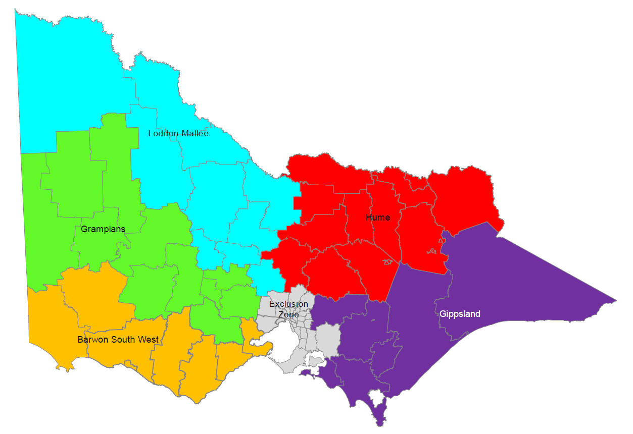

Figure 1. Commercial kangaroo harvest zones from 1 January 2025

The recommended maximum total take (total quota) across Victoria for 2025 is 207,800 kangaroos, consisting of 186,700 eastern grey kangaroos and 13,450 western grey kangaroos. Total quota includes both commercial harvesting and predicted take through the ATCW system. **Table 1** (next page) shows the estimated population, total quota, ACTW prediction and commercial quota of each grey kangaroo species in each harvest zone for 2025.

**Table 1. 2025 Population estimates, total quota, ATCW predictions and commercial quota for eastern grey kangaroos (EGK), western grey kangaroos (WGK) and both grey kangaroo species (Combined) across the five harvest zones in Victoria.**

|  |  |  |  |  |  |  |  |  |  |  |  |  |  |  |  |
| --- | --- | --- | --- | --- | --- | --- | --- | --- | --- | --- | --- | --- | --- | --- | --- |
| Harvest  zone | Population estimate | | | | | Total quota | | | ATCW prediction  (+10% buffer) | | | Commercial quota | | | |
|  | EGK | | WGK | | Combined | EGK | WGK | Combined | EGK | WGK | Combined | EGK | WGK | Combined | |
| Barwon  South West | 249,000 | | 12,000 | | 261,000 | 24,900 | 1,200 | 26,100 | 16,150 | 600 | 16,750 | 8,750 | 600 | 9,350 | |
| Grampians | 273,000 | | 112,000 | | 385,000 | 27,300 | 11,200 | 38,500 | 14,800 | 1,000 | 15,800 | 12,500 | 10,200 | 22,700 | |
| Loddon Mallee | 408,000 | | 87,000 | | 495,000 | 40,800 | 8,700 | 49,500 | 16,100 | 6,800 | 22,900 | 24,700 | 0 | 24,700 | |
| Hume | 771,000 | | - | | 771,000 | 77,100 | - | 77,100 | 39,000 | - | 39,000 | 38,100 | - | 38,100 | |
| Gippsland | 166,000 | | - | | 166,000 | 16,600 | - | 16,600 | 4,700 | - | 4,700 | 11,900 | - | 11,900 | |
| **TOTAL** | **1,867,000** | **211,000** | | **2,078,000** | | **186,700** | **21,100** | **207,800** | **90,750** | **8,400** | **99,150** | **95,950** | **10,800** | **106,750** |

#### Determining the commercial quota

As in previous years, DEECA has engaged ARI to provide recommendations on a sustainable commercial kangaroo harvest for Victoria – see the ARI report *Kangaroo harvest quotas for Victoria, 2025*.

The 2025 quota is based on statewide kangaroo population data and modelling and ARI recommendations on sustainable levels of take for each grey kangaroo species. An additional 10 per cent buffer has been added to predicted ATCW permits in 2025, to provide more certainty and consistency for industry throughout the year.

No quota has been issued in the Loddon Mallee zone for western grey kangaroos for 2025, as historically the level of take of this species within this zone (previously the Mallee harvest zone) has been higher than the recommended levels. This is consistent with the decision to issue no quota in the Mallee harvest zone in 2024.

DEECA regularly monitors the take of kangaroos through both the Kangaroo Harvesting Program and the ATCW system. If numbers are approaching the recommended maximum total take in any harvest zone, or if emergency events such as floods or bushfires are impacting kangaroo populations, commercial harvesting may be reduced, suspended or closed in affected areas.

#### Further information

For more detailed information on the calculation of the quota, refer to the ARI report, *Kangaroo harvest quotas for Victoria, 2025.*