# Grey-headed Flying-foxes in Victoria



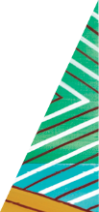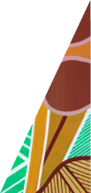

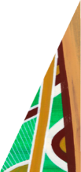

[deeca.vic.gov.au](https://delwpvicgovau.sharepoint.com/Users/fionadurante/Downloads/deeca.vic.gov.au)

Have you seen flying-foxes at night and wondered what they were up to? These fascinating bats often visit towns and cities[1], but also help care for our local forests.

Grey-headed Flying-foxes are one of the world’s largest flying mammals. They have black wings and grey-black body fur, with an orange neck and lighter grey fur on their heads. Their wings unfold up to one metre wide.

Grey-headed Flying-foxes are only found in Australia, from north Queensland, through New South Wales and Victoria into South Australia. In Victoria, Grey-headed Flying-foxes occur almost everywhere except the northwest. Little Red Flying-foxes also visit Victoria, mostly in northern areas.

Grey-headed Flying-foxes are threatened in Victoria and Australia-wide, mostly due to destruction of habitat[2]. Extreme heat, entanglement in fruit netting and barbed wire, and electrocution on powerlines also impact flying-foxes. Climate change may exacerbate threats such as extreme heat and food shortages.

#### Flying-foxes love flowers and fruit

Flying-foxes are nocturnal, meaning they’re most active at night. You may not notice them during the day, when they sleep, rest and interact in large camps. But towards dusk, the camps come alive, as flying-foxes get ready to fly out. They spend the night foraging across the landscape, returning to a camp just before dawn.

Grey-headed Flying-foxes eat flowers (pollen and nectar) and fruit from more than 100 species of native plants[3] as well as many exotic trees. They especially like flowering gums, using their long tongues to extract the nectar. You might see Grey-headed Flying-foxes in your garden at night, feeding on backyard trees such as figs and lilly-pilly. Sometimes they also eat leaves.

#### Flying-foxes are long-distance travellers

Flying-foxes are very good at moving around to find foods that are only available for a short time. While flying-foxes can fly up to 100 km at night to find food, most prefer to feed closer to home, within about 20 km.

Grey-headed Flying-foxes also move a lot between camps. Even though some camps may be used year-round, the composition of a flying-fox camp is very fluid – every day about 18% of the animals will likely move on to other areas[4]. While some flying-foxes may stay in a camp for several months, most visits are short-term and don’t last more than a week. On average they fly about 1,500 km a year between camps, with some animals travelling much further.

#### Flying-foxes are forest guardians

Flying-foxes are busy looking after our native forests. During their nightly travels, they spread pollen over long distances while they’re feeding on blossom. This helps to pollinate flowering trees and improve their genetic health. Flying-foxes can also disperse seeds across the landscape, supporting forest regeneration. By supporting forest health, flying-foxes help provide habitat for other plants and animals.

#### Living with flying-foxes

Admire flying-foxes from a distance and try not to disturb them.

If you are concerned about flying-foxes feeding in your garden, remember it’s only for a short time while trees are fruiting or flowering.

Find more information about living with flying-foxes at [www.wildlife.vic.gov.au/flying-foxes](http://www.wildlife.vic.gov.au/flying-foxes).

#### Staying safe around flying-foxes

Flying-foxes, like all wildlife, can be natural hosts to diseases that may be transmitted to humans. Never touch or handle flying-foxes. Always call a trained wildlife rescuer to assist. Find a local contact by calling 136 186 or use DEECA’s Help for Injured Wildlife Tool at [www.wildlife.vic.gov.au/hfiw](http://www.wildlife.vic.gov.au/hfiw).

Australian bat lyssavirus infection is a rare but serious disease. It is transmitted to people from infected bats through bites, scratches or contact with saliva or neural tissue to broken skin or the eyes, nose or mouth. Exposure to blood, urine or droppings is not known to transmit infection. If you are bitten or scratched by a bat, or exposed to bat saliva, wash the wound thoroughly, apply an antiseptic and get medical help immediately. Find more information from the Department of Health at <https://www.betterhealth.vic.gov.au/health/conditionsandtreatments/Australian-bat-lyssavirus>.

If your pet has come in contact with a flying-fox, contact your local vet or call the Emergency Animal Disease Watch Hotline on 1800 675 888.

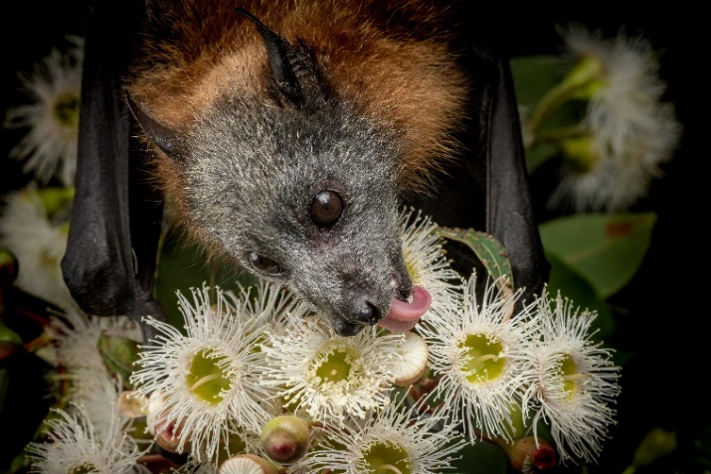



We acknowledge Victorian Traditional Owners and their Elders past and present as the original custodians of Victoria’s land and waters and commit to genuinely partnering with them and Victoria’s Aboriginal community to progress their aspirations.

© The State of Victoria Department of Energy, Environment and Climate Action August 2024.

All photos courtesy of Doug Gimesy.

Creative Commons

This work is licensed under a Creative Commons Attribution 4.0 International licence, visit the [Creative Commons website](http://creativecommons.org/licenses/by/4.0/) (<http://creativecommons.org/licenses/by/4.0/>).

You are free to re-use the work under that licence, on the condition that you credit the State of Victoria as author. The licence does not apply to any images, photographs or branding, including the Victorian Coat of Arms, and the Victorian Government and Department logos.

**ISBN** 978-1-76136-901-8 **(pdf/online/MS word)**

Disclaimer

This publication may be of assistance to you but the State of Victoria and its employees do not guarantee that the publication is without flaw of any kind or is wholly appropriate for your particular purposes and therefore disclaims all liability for any error, loss or other consequence which may arise from you relying on any information in this publication.

Accessibility

To receive this document in an alternative format, phone the Customer Service Centre on 136 186, email [customer.service@deeca.vic.gov.au](mailto:customer.service@deeca.vic.gov.au), or contact National Relay Service on 133 677. Available at [DEECA website](https://www.wildlife.vic.gov.au/our-wildlife/flying-foxes) (www.deeca.vic.gov.au).

1. Meade J, Martin JM & Welbergen JA (2021) Fast food in the city? Nomadic flying-foxes commute less and hang around for longer in urban areas. Behavioral Ecology, 32(6): 1151-1162.
2. DAWE (2021) National Recovery Plan for the Grey-headed Flying-fox ‘*Pteropus poliocephalus*’, Department of Agriculture, Water and the Environment, Canberra.
3. Eby P & Law B (2008) Ranking the feeding habitats of Grey-headed flying foxes for conservation management. A report for DECC (NSW) and DEWHA.
4. Welbergen JA et al. (2020) Extreme mobility of the world’s largest flying mammals creates key challenges for management and conservation. BMC Biology 18:101.