# Flying-foxes and powerlines

What to do if you find an electrocuted flying-fox

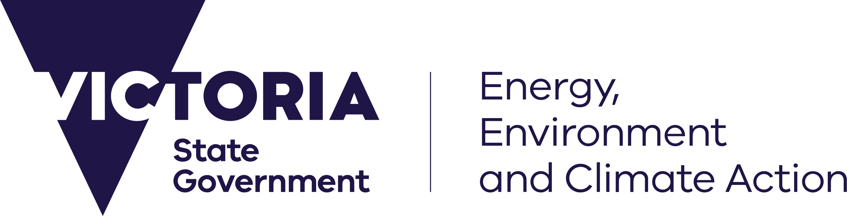

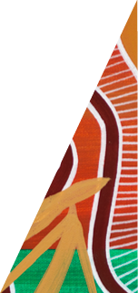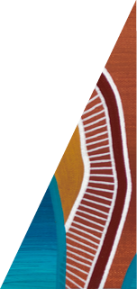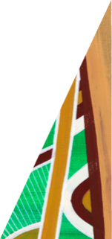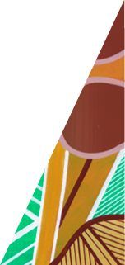

[deeca.vic.gov.au](https://delwpvicgovau.sharepoint.com/Users/fionadurante/Downloads/deeca.vic.gov.au)

Victoria is home to the Grey-headed Flying-fox, Australia’s largest flying mammal. They are easily recognised by their grey head, orange neck fur and large black wings.

Also known as fruit bats, flying-foxes feed on flowers and fruit from native and exotic trees. They use their excellent eyesight and sense of smell to find their food. Flying-foxes fly out to feed at night before returning at dawn to rest in large camps, often in towns and cities.

Grey-headed Flying-foxes move around a lot. Each night they can fly up to 100 km looking for food. They also regularly move between camps.

Grey-headed Flying-foxes are a threatened species. They are considered vulnerable in Victoria, nationally and internationally, primarily due to habitat destruction and effects of climate change.

As flying-foxes move through our neighbourhoods, they can get caught in barbed wire fences or fruit tree netting. They can also be electrocuted on powerlines.

### Electrocution on powerlines

Flying-foxes can be electrocuted on powerlines if their wings make contact with live wires or infrastructure, or if they fly too close to the lines.

In most cases, adult flying-foxes die if electrocuted. Young flying-foxes and carried pups often survive electrocution. Pups may still be with their mother or on the ground and you might hear them calling out. Injured animals can suffer and may pose a health risk to the public from bites or scratches. A small number of flying-foxes are natural hosts to Australian bat lyssavirus (ABLV). ABLV infection is a rare but serious disease. ABLV can be transmitted to people from infected bats via a bite, scratch, or contact with saliva or neural tissue to broken skin, eyes, nose or mouth. The most important thing to remember is your safety:

* Don’t assume a lifeless flying-fox is dead. If it is on the ground, use a shovel and gloves to gently move the animal to see if it’s alive or if it has a pup.
* Never attempt to touch a live flying-fox. Call a trained and vaccinated wildlife rescuer to assist.
* Never try to rescue or touch an animal caught in powerlines or on powerline infrastructure. Always call your electricity distributor.
* If you are bitten or scratched, or exposed to bat saliva, wash the wound thoroughly, apply an antiseptic and get medical help immediately.
* Do not directly handle flying-foxes and don’t touch a live flying-fox yourself.
* Call a wildlife rescuer if you see an electrocuted flying-fox on a powerline or a live flying-fox on the ground.
* Call your electricity distributor to remove dead flying-foxes from powerlines.

### Your help is needed

* If you see an electrocuted flying-fox on power lines, do not touch the animal. Call a wildlife rescuer to assess if the animal is dead or has a pup. Binoculars can help to spot a pup, which may be clinging to its mother’s chest. If a rescue is possible, the electricity distributor will also be needed onsite to assist.
* If you find a live flying-fox on the ground, do not touch it. Always call a wildlife rescuer to assist.
* Check a lifeless flying-fox on the ground is dead and doesn’t have a pup, by gently turning it over with a shovel. Wear gloves and avoid direct contact.
* Don’t directly handle dead flying-foxes if you need to remove one from your property. Use gloves and a shovel to put the animal in a strong plastic bag, double bag it and seal. Carcasses and gloves should be disposed of according to local government by-laws. Wash hands thoroughly with soap and dry afterwards.
* Call your local electricity distributor to remove dead flying-foxes from powerlines. Councils can assist to remove dead flying-foxes from nature strips.



We acknowledge Victorian Traditional Owners and their Elders past and present as the original custodians of Victoria’s land and waters and commit to genuinely partnering with them and Victoria’s Aboriginal community to progress their aspirations.

© The State of Victoria Department of Energy, Environment and Climate Action August 2024.

All photos courtesy of Doug Gimesy.

Creative Commons

This work is licensed under a Creative Commons Attribution 4.0 International licence, visit the [Creative Commons website](http://creativecommons.org/licenses/by/4.0/) (<http://creativecommons.org/licenses/by/4.0/>).

You are free to re-use the work under that licence, on the condition that you credit the State of Victoria as author. The licence does not apply to any images, photographs or branding, including the Victorian Coat of Arms, and the Victorian Government and Department logos.

**ISBN** 978-1-76136-880-6 **(pdf/online/MS word)**

Disclaimer

This publication may be of assistance to you but the State of Victoria and its employees do not guarantee that the publication is without flaw of any kind or is wholly appropriate for your particular purposes and therefore disclaims all liability for any error, loss or other consequence which may arise from you relying on any information in this publication.

Accessibility

To receive this document in an alternative format, phone the Customer Service Centre on 136 186, email [customer.service@delwp.vic.gov.au](mailto:customer.service@delwp.vic.gov.au), or contact National Relay Service on 133 677. Available at [DEECA website](http://www.wildlife.vic.gov.au/our-wildlife/flying-foxes/living-with-flying-foxes) (www.deeca.vic.gov.au).

### Contacts

To find a local wildlife rescuer, shelter operator or foster carer, call **136 186**, or visit DEECA’s Help for Injured Wildlife Tool at [www.wildlife.vic.gov.au/hfiw](http://www.wildlife.vic.gov.au/hfiw).

Find your electricity distributor using DEECA’s online map at [www.energy.vic.gov.au/households/find-your-energy-distributor](http://www.energy.vic.gov.au/households/find-your-energy-distributor). Victoria’s five distributors are:

* Ausnet Services: eastern Victoria and Melbourne’s outer northern and eastern suburbs **1300 360 795**
* CitiPower: Melbourne city and inner suburbs **1300 301 101**
* Jemena: Melbourne’s northern and north-western suburbs **1300 131 871**
* Powercor: western Victoria and Melbourne’s western suburbs **13 22 06**
* United Energy Distribution: Melbourne’s southern suburbs and Mornington Peninsula **1300 131 689**