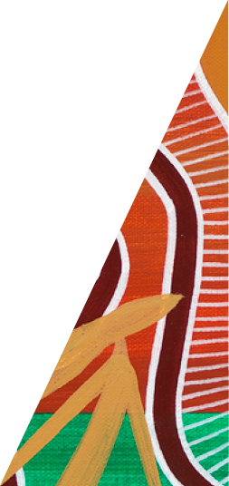Kangaroo Harvesting Program

Annual Report 2024

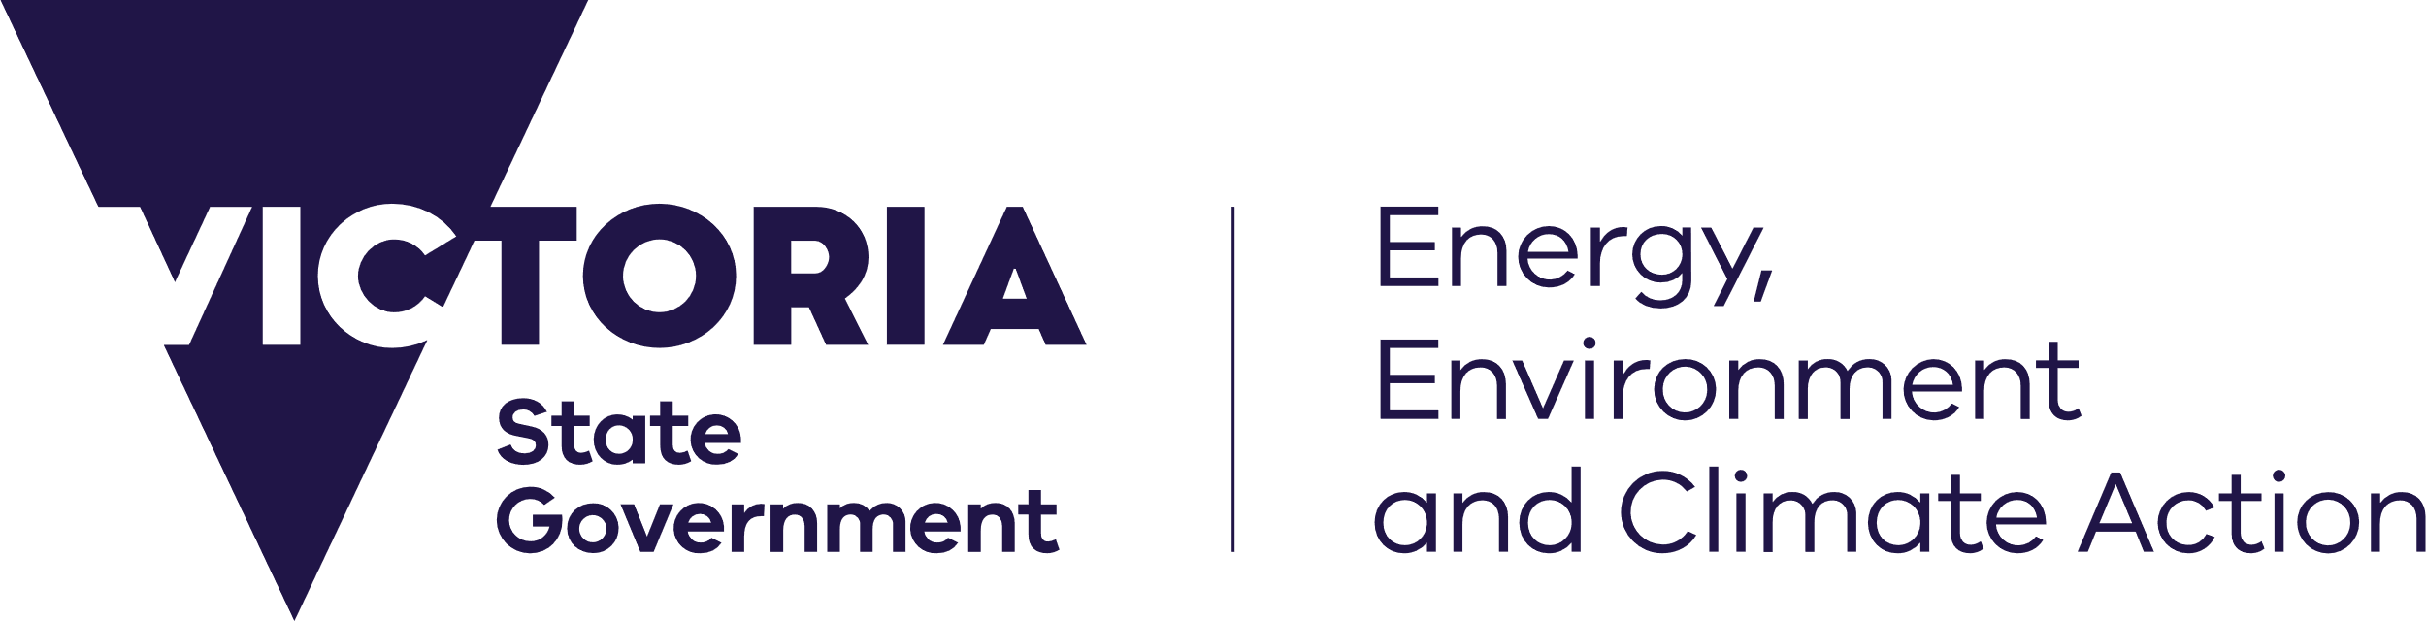



[deeca.vic.gov.au](https://delwpvicgovau-my.sharepoint.com/Users/fionadurante/Downloads/deeca.vic.gov.au)

Acknowledgements

The Department of Energy, Environment and Climate Action acknowledges the Department of Jobs, Skills, Industry and Regions for their administration of the Kangaroo Harvesting Program and their contributions to this report.



We acknowledge and respect Victorian Traditional Owners as the original custodians of Victoria’s land and waters, their unique ability to care for Country and deep spiritual connection to it.

We honour Elders past and present whose knowledge and wisdom   
has ensured the continuation of culture and traditional practices.

DEECA is committed to genuinely partnering with Victorian Traditional Owners and Victoria’s Aboriginal community to progress their aspirations.

© The State of Victoria Department of Energy, Environment and Climate Action March 2025.

Creative Commons

This work is licensed under a Creative Commons Attribution 4.0 International licence, visit the [Creative Commons website](http://creativecommons.org/licenses/by/4.0/) (<http://creativecommons.org/licenses/by/4.0/>).

You are free to re-use the work under that licence, on the condition that you credit the State of Victoria as author. The licence does not apply to any images, photographs, or branding, including the Victorian Coat of Arms, and the Victorian Government and Department logos.

ISSN – 2653-8288 **Online** (**pdf/word**)

Disclaimer

This publication may be of assistance to you, but the State of Victoria and its employees do not guarantee that the publication is without flaw of any kind or is wholly appropriate for your particular purposes and therefore disclaims all liability for any error, loss or other consequence which may arise from you relying on any information in this publication.

Accessibility

To receive this document in an alternative format, phone the Customer Service Centre on 136 186, email [customer.service@delwp.vic.gov.au](mailto:customer.service@delwp.vic.gov.au), or contact National Relay Service on 133 677. Available at [DEECA website](http://www.deeca.vic.gov.au/) (www.deeca.vic.gov.au).

Contents

Introduction 2

Kangaroo Harvesting Program 2

ATCW system 2

2024 commercial quota 3

Adjustments to commercial quota 3

Summary of 2024 kangaroo take 5

Commercial take 5

ATCW take 7

Total take (Commercial and ATCW take combined) 8

Harvester authorisations and compliance 9

Summary 9

General Program updates 10

2025 quota 10

Kangaroo Harvest Management Plan 2024-2028 10

Emergency events 10

2024 statewide kangaroo population survey 10

Research and development 11

Appendix A: 2024 KHP Harvest Zones 12

# Introduction

## Kangaroo Harvesting Program

Grey Kangaroos have been commercially harvested in Victoria since 1 October 2019 through the Kangaroo Harvesting Program (KHP).

The KHP Annual Report 2024 (the report) has been developed in line with the public reporting requirements under the *Kangaroo Harvest Management Plan (KHMP) 2024-2028* (DEECA, 2023), to publish the annual harvesting figures and compliance activities of the KHP. It captures relevant information on the implementation of the KHP from 1 January 2024 until 31 December 2024.

The report also includes data on Authority to Control Wildlife (ATCW) authorisations issued for Grey Kangaroos, as these are considered in determining the annual commercial quota and any adjustments to the commercial quota. The ATCW system allows for the lethal control of kangaroos where they are causing damage to property, posing a risk to human health and safety, or impacting environmental values.

In 2024 the KHP operated within seven Harvest Zones across Victoria. A map of Harvest Zones and corresponding local government areas is provided in **Appendix A**. Both Eastern Grey Kangaroos (EGK) and Western Grey Kangaroos (WGK) can be harvested through the KHP.

## ATCW system

Sometimes wildlife cause damage to property or farmland or can adversely impact the environment. Wildlife can also pose a threat to human safety, or where the species is over-abundant, may lead to animal welfare issues. In these cases, landholders and land managers may apply for an ATCW to manage the impacts of wildlife.

Wildlife control must ensure animal welfare and environmental values are protected.

The Conservation Regulator undertakes rigorous assessments of all ATCW applications. This ensures that claims of damage are substantiated, and all practical non-lethal measures have been exhausted prior to any lethal control being approved. This includes consideration of exclusion measures such as fencing or netting where they can be practically applied.

ATCWs for kangaroos can be issued to private landholders and public land managers. All ATCWs include strict conditions to ensure animals are controlled humanely. ATCW permits authorise a maximum number of kangaroos that can be lethally controlled by the permit holder. The actual numbers of kangaroos controlled through permits tend to be lower than the maximum.

More information about the KHP, KHMP and ATCWs can be found online:

* KHP: [**Kangaroo Harvesting Program | djsir.vic.gov.au**](https://djsir.vic.gov.au/game-hunting/kangaroo-harvesting)
* KHMP:[**Kangaroo Harvest Management Plan | wildlife.vic.gov.au**](https://www.wildlife.vic.gov.au/our-wildlife/kangaroo-harvesting-program)
* ATCWs: [**Wildlife management and control authorisations | www.vic.gov.au**](https://www.vic.gov.au/wildlife-management-and-control-authorisations)

# 2024 commercial quota

The Department of Energy, Environment and Climate Action (DEECA) set the 2024 commercial quota based on recommendations provided by the Arthur Rylah Institute for Environmental Research (ARI) in the report *Kangaroo harvest quotas for Victoria 2024* (Ramsey, 2023)*.*

ARI modelling recommends that no more than 10 per cent of Grey Kangaroos should be taken each year through commercial harvesting and the ATCW system combined to ensure sustainable kangaroo populations. An annual take of 10 to 20 per cent of kangaroo populations is considered sustainable.

ARI uses a spatial harvest model to make recommendations on kangaroo harvest quotas. The model considers results from the most recent statewide kangaroo population survey, contemporary environmental variables such as rainfall, and historical kangaroo control from KHP harvest data and approved ATCW permit data to predict changes in kangaroo populations for years where no survey is undertaken. The 2024 quota was set using results from the 2022 population survey.

As recommended in the ARI quota report, no commercial quota was assigned to the Mallee Harvest Zone in 2024. This recommendation was based on the prediction that levels of take through the ATCW system would exceed the recommended total quota for the Mallee (if maximum allowable control was undertaken).

## Adjustments to commercial quota

DEECA reviews the commercial quota each month and can make adjustments to quarterly quota releases to ensure take is sustainable. Considerations are given to approvals under the ATCW system, remaining commercial quota and kangaroo populations at Zone and statewide levels.

DEECA made two adjustments to the commercial quota in 2024.

### July 2024

DEECA reduced the annual commercial quota by 13,300 kangaroos for the remainder of the harvest year.

ARI re-analysed the 2022 aerial kangaroo survey data using an update of the effective survey area which excluded small areas of unsuitable habitat such as waterbodies and regional town centres. This resulted in a revision of the estimated statewide population of Grey Kangaroos, from 2,363,850 to 2,230,500. Subsequently, the annual commercial quota was reduced from 155,650 to 142,350 kangaroos.

***All references to estimated kangaroo populations and total quota in this report are based on revisions made in July 2024.***

### September 2024

DEECA reduced the commercial quota again in September 2024, by withdrawing the final quota release for 2024. The change was made due to higher than predicted levels of ATCW permits being issued. This reduced the annual commercial quota from 142,350 to 111,575 kangaroos.

***Unless specified otherwise, all references to available commercial quota in this report are based on revisions made in September 2024.***

#### Summary of 2024 quota adjustments

Table 1: Commercial kangaroo quotas for Victoria (1 January – 31 December 2024)

|  |  |  |  |  |
| --- | --- | --- | --- | --- |
| Harvest Zone | Estimated kangaroo population* | Original commercial quota  (Jan 2024) | Revised commercial quota  (Jul 2024) | Revised commercial quota  (Sep 2024) |
| Central | 761,500 | 61,700 | 55,800 | 43,900 |
| Gippsland | 158,000 | 13,700 | 11,850 | 9,375 |
| Lower Wimmera | 538,000 | 39,000 | 37,200 | 28,600 |
| Mallee | 55,500 | - | - | - |
| North East | 337,000 | 8,100 | 6,200 | 5,225 |
| Otway | 175,000 | 15,350 | 13,950 | 11,000 |
| Upper Wimmera | 205,500 | 17,800 | 17,350 | 13,475 |
| **Statewide total** | **2,230,500** | **155,650** | **142,350** | **111,575** |

*\* From revised estimate in July 2024.*

# Summary of 2024 kangaroo take

## Commercial take

### Summary

Overall, 81,160 kangaroos – or 3.6 per cent of the estimated population (within the designated Harvest Zones) was harvested through the KHP in 2024. **Table 2** summarises the commercial take of kangaroos in each Harvest Zone.

In 2024:

* 8,928 more kangaroos were harvested (81,160) compared to 2023 (72,232). The use of commercial quota varied between Harvest Zones.
* 72.7 per cent of the available commercial quota was used by harvesters, compared to 43 per cent of available commercial quota that was used in 2023.

Table 2: Commercial take of kangaroos (1 January – 31 December 2024)

|  |  |  |  |  |
| --- | --- | --- | --- | --- |
| Harvest Zone | Commercial quota available | Commercial  quota harvested | Available  commercial quota harvested (%) | Harvest Zone population harvested (%) |
| Central | 43,900 | 33,801 | 77.0 | 4.4 |
| Gippsland | 9,375 | 6,903 | 73.6 | 4.4 |
| Lower Wimmera | 28,600 | 23,904 | 83.6 | 4.4 |
| Mallee | - | - | - | - |
| North East | 5,225 | 4,246 | 81.3 | 1.3 |
| Otway | 11,000 | 8,354 | 75.9 | 4.8 |
| Upper Wimmera | 13,475 | 3,952 | 29.3 | 1.9 |
| **Statewide total** | **111,575** | **81,160** | **72.7** | **3.6** |

Upon completion of each harvest job, harvesters are required to report on the number of kangaroos harvested, the species, sex and whether any dependant young were euthanised.

#### Species of harvested kangaroos

Harvesters reported 1,497 western grey kangaroos taken from the total kangaroos harvested through the KHP in 2024**.**

#### Sex ratio of harvested kangaroos

Harvesters reported 27,314 female kangaroos were taken from the total kangaroos harvested through the KHP in 2024.

There is a known bias towards harvesting male kangaroos in commercial harvest programs. The ecological impact of male harvesting bias was considered by ARI in the report *A spatial harvest model for kangaroo populations in Victoria* (Scroggie and Ramsey, 2020). The report found there is minimal ecological risk to kangaroo populations when harvesting programs target males in preference to females, where regular monitoring occurs to ensure overall kangaroo harvesting is sustainable.

#### Dependant young

Harvesters reported 23,488 dependant young were euthanised due to harvesting activities in 2024. Dependant young of harvested female kangaroos must be euthanised humanely in line with requirements under the *National Code of Practice for the Humane Shooting of Kangaroos and Wallabies for Commercial Purposes* (AgriFutures, 2020).

The number of dependant young euthanised does not contribute to the data used to determine the commercial quota. The quota is determined using modelling and population estimates from aerial and ground surveys and these surveys do not count dependant young.

## ATCW permits

### Summary

ATCW permit figures from the Conservation Regulator are used to determine sustainable levels of take through the KHP. The number of Grey Kangaroos approved for control under an ATCW in each KHP Harvest Zone from 1 January to 31 December 2024 is shown in **Table 4**.

It is important to note the ATCW figures reported are the maximum numbers of kangaroos that were approved for control during this period. The actual number controlled by a landholder may be lower than the maximum authorised.

The number of kangaroos approved for control through ATCWs was higher than ARI’s prediction for 2024. Long term averages from previous years are used to inform ATCW predictions for the following year. There is no cap on the number of ATCW applications or approvals that can be issued.

The higher than predicted number of kangaroos approved for control under ATCWs may be a result of landholders experiencing increased impacts from kangaroos. The reason for this is not conclusive but may be due to favourable environmental conditions in recent years resulting in high reproduction rates in kangaroos, followed by dry seasonal conditions pushing more kangaroos on to pasture, crops and on-farm water sources.

Table 4: Maximum number of Grey Kangaroos (EGK and WGK combined) approved for control under an ATCW from 1 January to 31 December 2024

|  |  |  |  |
| --- | --- | --- | --- |
| KHP Harvest Zone | Predicted ATCWs | Kangaroos approved for control (ATCW) | Grey Kangaroo pop. approved for control via ATCW (%) |
| Central | 20,350 | 27,669 | 3.6 |
| Gippsland | 3,950 | 6,642 | 4.2 |
| Lower Wimmera | 16,600 | 31,664 | 5.9 |
| Mallee | 6,300 | 6,541 | 11.8 |
| North East | 27,500 | 35,870 | 10.6 |
| Otway | 3,550 | 5,957 | 3.4 |
| Upper Wimmera | 2,450 | 4,480 | 2.2 |
| **Statewide total** | **80,700** | **118,823** | **5.3** |

#### ATCWs outside of Harvest Zones

Data on ATCWs issued for Grey Kangaroos outside of the seven KHP Harvest Zones is not included in this report. The Conservation Regulator publishes annual ATCW data for all species across Victoria on its website: [**vic.gov.au/operational-licences-permits-issued-conservation-regulator**](http://www.vic.gov.au/operational-licences-permits-issued-conservation-regulator)

## Total take (Commercial and ATCW take combined)

### Summary

In 2024, the total take of Victoria’s Grey Kangaroo population through the KHP and ATCW system within the seven Harvest Zones was 9 per cent (199,983) (**Table 5**). This is within the 10 per cent maximum (223,050) recommended by ARI. The total take in three Zones (Mallee, Lower Wimmera and North East) was above the recommended maximum of 10 per cent.

Prior to the quarter 4 quota release DEECA identified that total take in the most Harvest Zones was likely to exceed the recommended maximum if the full allocation of commercial quota was released. In response to higher than predicted ATCW permits being applied for, DEECA withdrew the final commercial quota release for 2024. However, the risk of total take exceeding recommended levels could not be eliminated in some Harvest Zones as the withdrawal of the remaining quota did not affect landholders ability to apply for ATCWs to control kangaroos.

Table 5: Total kangaroo take (1 January – 31 December 2024)

|  |  |  |  |  |  |
| --- | --- | --- | --- | --- | --- |
| Harvest Zone | Total quota (Predicted ATCW and commercial quota available) | KHP  (Commercial quota harvested) | ATCW  (Maximum kangaroos approved for control) | Total take  (ATCW and KHP) | Total take  (% of population) |
| Central | 76,150 | 33,801 | 27,669 | 61,470 | 8.1 |
| Gippsland | 15,800 | 6,903 | 6,642 | 13,545 | 8.6 |
| Lower Wimmera | 53,800 | 23,904 | 31,664 | 55,568 | 10.3 |
| Mallee | 5,550 | - | 6,541 | 6,541 | 11.8 |
| North East | 33,700 | 4,246 | 35,870 | 40,116 | 11.9 |
| Otway | 17,500 | 8,354 | 5,957 | 14,311 | 8.2 |
| Upper Wimmera | 20,550 | 3,952 | 4,480 | 8,432 | 4.1 |
| **Statewide total** | **223,050** | **81,160** | **118,823** | **199,983** | **9.0** |

#### Mallee Zone

The number of kangaroos approved for control through the ATCW system in the Mallee Zone was above the recommended maximum. As in other years, demand for ATCW permits was high, likely due to environmental conditions as discussed above. DEECA made the decision that no commercial quota be issued (or used) in this Zone in 2024 (see 2024 commercial quota).

#### Lower Wimmera and North East Zones

The total take in these two Zones exceeded the recommended maximum by 0.3 per cent (Lower Wimmera) and 1.9 per cent (North East) due to authorised ATCW control being higher than predicted. DEECA identified higher than predicted levels of ATCWs across the state prior to the final release of commercial quota and made the decision to withdraw the final release of quota. This was to mitigate the impact of higher than predicted ATCWs numbers (see Adjustments to commercial quota). As described above, it is likely that the actual number of kangaroos controlled is lower, as ATCW figures reported are the maximum numbers of kangaroos that were approved for control (see ATCW take).

# Harvester authorisations and compliance

## Summary

The Game Management Authority (GMA) delivers commercial harvester authorisations and compliance activities as an agent of the Department of Jobs, Skills, Industry and Regions. Compliance activities summarised below do not include compliance for kangaroo control through the ATCW system. This is administered by the Conservation Regulator and is outside the scope of this report.

In 2024, compliance activities were undertaken in accordance with the five compliance priorities (Harvester Competency, Animal Welfare, Sustainability, Authorisations, and Public Safety) of the 2024 KHP Compliance Plan.

There were 29 active harvesters in 2024. An active harvester under the 2024 KHP Compliance Plan, is a harvester who was active throughout the previous four quarters. As there was no quota released in quarter 4, these figures were taken from the quarter 3 up to September 30, 2024.

Table 6: Harvester authorisations

|  |  |
| --- | --- |
| Activity | Total |
| Number of applications for authorisations received | 17 |
| Number of applications authorised after meeting requirements | 13 |
| Number of authorisations suspended or cancelled | 0 |

Table 7: Harvesters who received commercial quota for each Harvest Zone*

|  |  |
| --- | --- |
| Harvest Zone | Total |
| Central | 54 |
| Gippsland | 27 |
| Lower Wimmera | 44 |
| Mallee | 0 |
| North East | 24 |
| Otway | 31 |
| Upper Wimmera | 19 |

*\*Harvesters may operate across more than one Harvest Zone*

Table 8: Compliance activities 2024 summary

|  |  |
| --- | --- |
| Activity | Total |
| Number of audits conducted on harvester return data | 1,152 |
| Percentage of active harvesters subject to programmed in-field audits | 75% |
| Number of investigations | 18 |
| Number of offences substantiated | 0 |

# General Program updates

## 2025 quota

The 2025 quota is based on the ARI’s recommendation in the report *Kangaroo harvest quotas for Victoria, 2025* (Scroggie and Moloney, 2024).

When setting the commercial quota, the number of kangaroos predicted to be controlled under the ATCW system is based on long term averages, however, there is no way to predict ahead of time exactly how many ATCW permits will be granted in a year.

In response to the higher than predicted levels of ATCW control across all Harvest Zones in 2024, DEECA has applied an additional 10 per cent buffer to the predicted ATCW permits in 2025. This has led to the commercial quota being set lower to account for the potential for more ATCW control and will also provide more certainty and consistency for the industry throughout the year.

Commercial quota will continue to be released quarterly in 2025 – scheduled for January, April, July, and October. This enables DEECA to monitor and adjust the quota release throughout the year in response to any events, such as bushfires or flooding, that may threaten the sustainability of kangaroo populations.

## Kangaroo Harvest Management Plan 2024-2028

The KHMP 2024-2028 was approved by the DEECA Secretary and came into effect on 1 January 2024.

### Approval of KHMP for international export

The Australian Government regulates the export of wildlife products from Australia. To ensure that products exported are obtained from an ecologically sustainable program, a Wildlife Trade Management Plan (WTMP) is required.

To allow kangaroo products harvested through the KHP to be exported internationally, the KHMP 2024-2028 was submitted to the Department of Climate Change, Energy, the Environment and Water (DCCEEW) for approval as a WTMP.

As part of the approval process, DCCEEW conducted a public consultation and assessed the KHMP 2024-2028 against the *Environment Protection and Biodiversity Conservation Act 1999*.

The Plan was declared an approved WTMP by the Commonwealth Minister for the Environment and Water and came into effect on [**8 September 2024**](https://www.wildlife.vic.gov.au/__data/assets/pdf_file/0025/718171/Wildlife-Trade-Management-Plan-Declaration.pdf) (see [Wildlife Trade Management Plan for the Commercial Harvest of Kangaroos in Victoria 2024–2028 - DCCEEW](https://www.dcceew.gov.au/environment/wildlife-trade/publications/wildlife-trade-management-plan-for-commercial-harvest-kangaroos-victoria-2024-2028) for more information).

## Emergency events

In 2024, four significant bushfires occurred, including the Mt Stapylton, Bellfield, Bayindeen and Yarram Gap Road (Grampians) fires, which required the deployment of accredited Wildlife Field Assessment Teams. These teams undertook welfare assessments and where necessary, euthanasia of wildlife, including kangaroos across and adjacent to the firegrounds.

DEECA Wildlife Field Assessment Teams euthanised just over 680 kangaroos on welfare grounds on and adjacent to the fire grounds in the 2024 calendar year.

Field assessment activities at the Yarram Gap Road fire continued into early 2025. The number of kangaroos euthanised from 1 January 2025 will be captured in the next years report.

## 2024 statewide kangaroo population survey

Kangaroo populations in Victoria are estimated through modelling of data from statewide aerial and ground surveys. Aerial surveys are untaken biennially and ground surveys periodically as recommended by ARI. The most recent aerial and ground surveys were conducted in September 2024 and the results were used to produce an updated estimate of kangaroo abundance across the state. The 2024 survey builds on data gathered from previous surveys in 2017, 2018, 2020 and 2022.

The most recent statewide survey showed a stability in total abundance of Eastern and Western Grey Kangaroos when compared to the 2022 survey, with increases and decreases in certain parts of the state. Across the entire area surveyed, the estimated total abundance in 2024 for both Grey Kangaroo species combined was 2.31 million.

As Harvest Zone boundaries changed from 1 January 2025, ARI undertook work to provide population estimates of the entire survey area (referred to above) and for the five new Harvest Zones which no longer include 10 LGAs previously part of the KHP. Developing estimates for the entire survey area allows for continued analysis of kangaroo population trends since 2017. Whereas the estimates for the five new Harvest Zones are used to develop the 2025 quotas.

The abundance of kangaroos in Victoria uses widely accepted scientific principles and modelling as used by other states. The results from the 2024 survey are provided in *State-wide abundance of kangaroos in Victoria, 2024: Results from the 2024 aerial survey* (Scroggie and Moloney, 2024).

## Research and development

### New model-based approach to estimating kangaroo populations

ARI have developed a new methodology for modelling Grey Kangaroo abundance across the state, which uses a model-based distance sampling approach and replaces the design-based approach used previously.

A paper, *Spatio-temporal trends in the abundance of grey kangaroos in Victoria, Australia* (Scroggie, Moloney and Ramsey, 2025) on the new methodology has been published in the journal *Wildlife Research*.

# Appendix A: 2024 KHP Harvest Zones

**Figure 1. Map of Victorian kangaroo Harvest Zones in 2024**

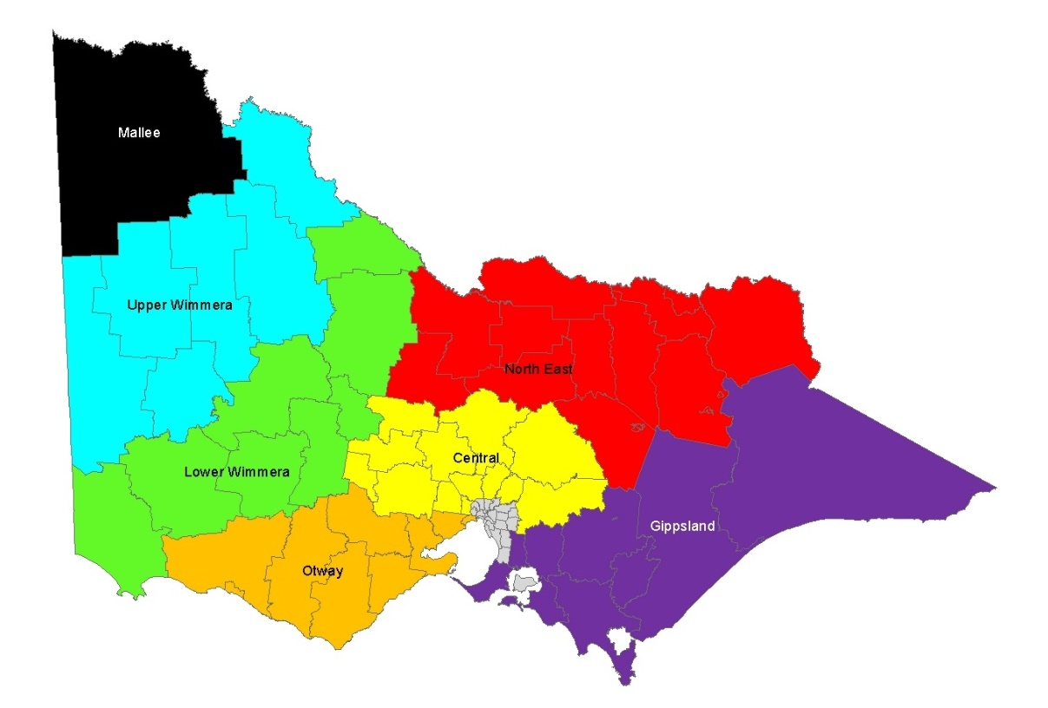

Table 1. Local Government Areas contained in each kangaroo Harvest Zone in Victoria

|  |  |  |  |  |  |  |  |
| --- | --- | --- | --- | --- | --- | --- | --- |
| **Central** | **Gippsland** | **Lower Wimmera** | **Mallee** | **North East** | **Otway** | **Upper Wimmera** | |
| Ballarat  Brimbank  Hepburn  Hume  Macedon Ranges  Melton  Mitchell  Moorabool  Mt Alexander  Murrindindi  Nillumbik  Whittlesea  Yarra Ranges | Bass Coast  Baw Baw  Cardinia  Casey  East Gippsland  Latrobe  Mornington Peninsula  South Gippsland  Wellington | Ararat  Central Goldfields  Gannawarra  Glenelg  Loddon  Northern Grampians  Pyrenees  Southern Grampians | Mildura | Alpine  Benalla  Campaspe  Greater Bendigo  Greater Shepparton  Indigo  Mansfield  Moira  Strathbogie  Towong  Wangaratta  Wodonga | Colac Otway  Corangamite  Golden Plains  Greater Geelong  Hobsons Bay  Moyne  Surf Coast  Warrnambool  Wyndham | Buloke  Hindmarsh  Horsham  Swan Hill  West Wimmera  Yarriambiack | |
|  | | | | | | |
| **Exclusion Zone (No commercial harvesting, ATCWs only)** | | | | | | |
| Banyule, Bayside, Boroondara, Greater Dandenong, Darebin, Frankston, French Island, Glen Eira, Kingston, Knox, Manningham, Maribyrnong, Maroondah, Melbourne, Monash, Moonee Valley, Merri-bek, Port Phillip, Queenscliff, Stonnington, Whitehorse, Yarra City | | | | | | | |

References

AgriFutures 2020*. National Code of Practice for the Humane Shooting of Kangaroos and Wallabies for Commercial Purposes.* AgriFutures Australia Publication No. 20-126.

Department of Energy, Environment and Climate Action (DEECA) 2023. *Victorian Kangaroo Harvest Management Plan 2024-2028*. Department of Energy, Environment, and Climate Action, Victoria.

Moloney, P.D., Ramsey, D.S.L., and Scroggie, M.P. (2023). *State-wide abundance of kangaroos in Victoria: Results from the 2022 aerial survey*. Arthur Rylah Institute for Environmental Research Technical Report Series No. 356. Department of Energy, Environment and Climate Action, Heidelberg, Victoria.

Ramsey, D.S.L. (2023). *Kangaroo harvest quotas for Victoria, 2024*. *Arthur Rylah Institute for Environmental Research Technical Report Series No. 371*. Department of Energy, Environment, and Climate Action, Heidelberg, Victoria

Scroggie, M.P. and Moloney, P.D. (2024). *Kangaroo harvest quotas for Victoria, 2025*. *Arthur Rylah Institute for Environmental Research Technical Report Series No. 384*. Department of Energy, Environment, and Climate Action, Heidelberg, Victoria.

Scroggie, M.P. and Moloney, P.D. (2024). *State-wide abundance of kangaroos in Victoria, 2024: Results from the 2024 aerial survey*. *Arthur Rylah Institute for Environmental Research Technical Report Series No. 385*. Department of Energy, Environment, and Climate Action, Heidelberg, Victoria.

Scroggie, M.P., Moloney, P. and Ramsey, D.S.L. (2025). *Spatio-temporal trends in the abundance of grey kangaroos in Victoria, Australia*. Wildlife Research, 52(2).

Scroggie, M.P. and Ramsey, D.S.L. (2020). *A spatial harvest model for kangaroo populations in Victoria*. *Arthur Rylah Institute for Environmental Research Technical Report Series No. 315*. Department of Energy, Environment and Climate Action, Heidelberg, Victoria.